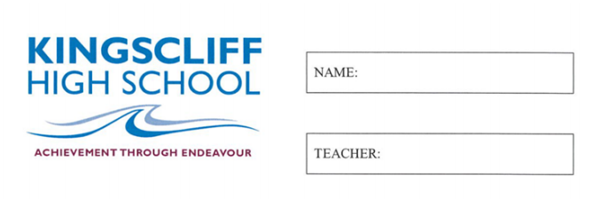

MATHEMATICS

Year 7

Practice Exam 4

2026

Time allowed: 50 mins
5 mins reading time
Instructions  1. Attempt all questions  2. Show working where needed  3. A calculator is NOT permitted |  | Sections and Marks  Part A (Multiple Choice) – 15 Marks  Part B (Calculations) – 30 Marks  Part C (Data and Probability) – 18 Marks  Total – 63 Marks

Part A
1. | Which word means ‘add up all the values and divide by how many values there are’?  a) Range b) Mean  c) Mode d) Median
2. | The mode of 8, 3, 5, 3, 9, 5, 3 is:  a) 3 b) 5  c) 8 d) 9
3. | Using the order of operations, (8 + 4) ÷ 2 × 3 =  a) 2 b) 18  c) 14 d) 36
4. | Which shows 7, −2, 4, 0 in descending order?  a) −2, 0, 4, 7 b) 7, 4, 0, −2  c) 0, −2, 4, 7 d) 7, 4, −2, 0
5. | Which number has a 3 in the tenths place?  a) 3.81 b) 0.03  c) 8.31 d) 1.003
6. | Which of these is the same as 6 × 6 × 6?  a) 6 × 3 b) 6³  c) 3⁶ d) 6 + 6 + 6
7. | A variable is best described as:  a) A number that never changes  b) A letter or symbol that stands for a number  c) Any number bigger than 10  d) The answer to a sum
8. | Two angles of a triangle add up to 125°. The third angle is:  a) 35° b) 55°  c) 65° d) 235°
9. | In an isosceles triangle, one of the two equal angles is 70°. The other equal angle is:  a) 20° b) 40°  c) 70° d) 110°
10. | Which of these is NOT a perimeter problem?  a) Fencing around a back yard  b) Ribbon around the edge of a card  c) Carpet to cover a bedroom floor  d) A border around a poster
11. | Which number lies between −6 and −2 on a number line?  a) −8 b) −4  c) 0 d) 3
12. | Which outcome is NOT in the sample space for rolling a standard six-sided die?  a) 1 b) 3  c) 6 d) 7
13. | If P(rain) = 1, then rain is:  a) Impossible b) Unlikely  c) An even chance d) Certain
14. | An angle of exactly 180° is called:  a) Right b) Reflex  c) Straight d) Obtuse
15. | Angles that form an ‘F’ shape on parallel lines are called:  a) Alternate b) Co-interior  c) Corresponding d) Vertically opposite

Part B
1. | Calculate the missing angle and provide working out. | 2  marks
  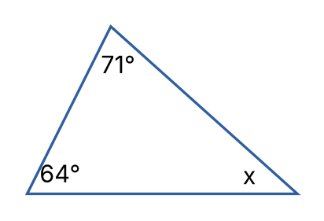 | _____________________  _____________________  _____________________  _____________________
2. | Calculate the size of the exterior angle marked a° and provide working out. | 2  marks
  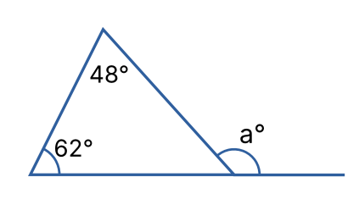 | _____________________  _____________________  _____________________  _____________________
3. | State True or False for each of the following:  a) 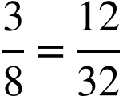 b) 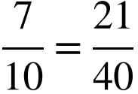 | 2  marks
4. | Calculate the following:  a) 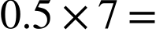 b) 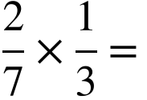 | 2  marks
5. | Calculate the following:  a) 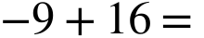  b) 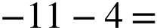  c) 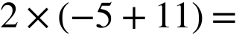 | 3  marks
6. | Convert into a mixed number:  a) 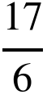  Convert into an improper fraction:  b) 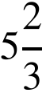 | 2  marks
7. | Write an algebraic expression for each statement. Use to represent the number:  i) The number multiplied by 9  ii) 12 take away the number | 2  marks
8. | If 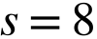, 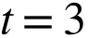 and 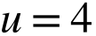  Solve the following by substitution:  i) 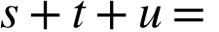  ii) 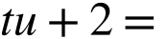 | 2  marks
9. | Simplify the following:  i) 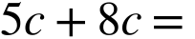  ii) 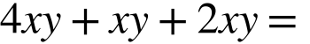  iii) 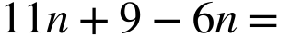  iv) 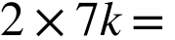 | 4  marks
10. | Calculate the following (use a mental or written strategy):  i) 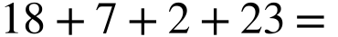  ii) 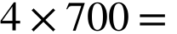  iii) 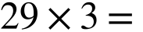 | 3  marks
11. | Solve the following equations:  i) 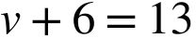  ii) 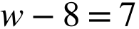  iii) 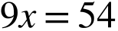  iv) 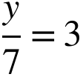  v) 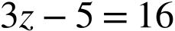  vi) 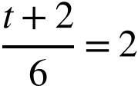 | 6  marks

Part C
12. | The list below shows the number of pets owned by each student in 7C:  1 0 2 1 3 2 1 0 1 2 4  1 0 2 1 3 1 9 2 1 2 0  i) Construct a dot plot from the above set of data  ii) How many students are in 7C?  iii) What is the mode?  iv) What is the range?  v) How many students own fewer than 2 pets?  vi) Is there an outlier? If so, what is it? | 7  marks
13. | Observe the following set of data:  12, 8, 10, 6, 9, 11, 7, 13, 5  Calculate the following:  i) The mean  ii) The median  If 19 was added to the data set, what would be:  iii) The new median?  iv) The new mean? | 4  marks
14. | Observe the following graph and answer the questions below.  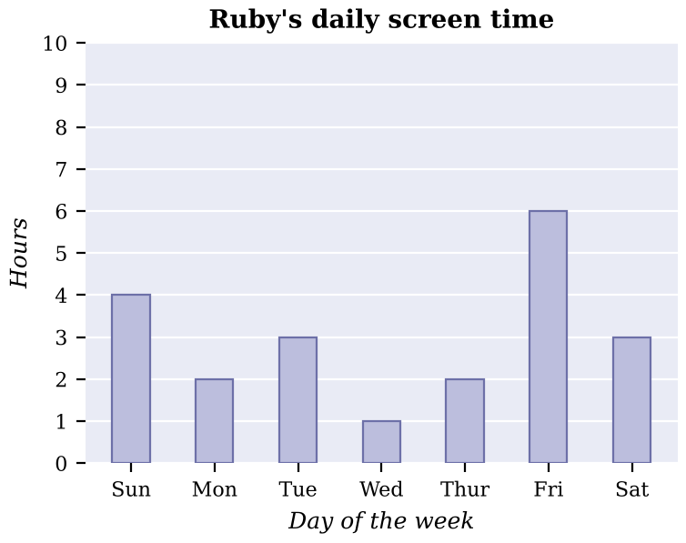  i) How many hours did Ruby spend on a screen on Wednesday?  ii) On which day did Ruby spend the most time on a screen?  iii) How many hours did Ruby spend on a screen over the whole week shown?  iv) What fraction of Sunday did Ruby spend on a screen? Give your answer in simplest form. | 4  marks
15. | 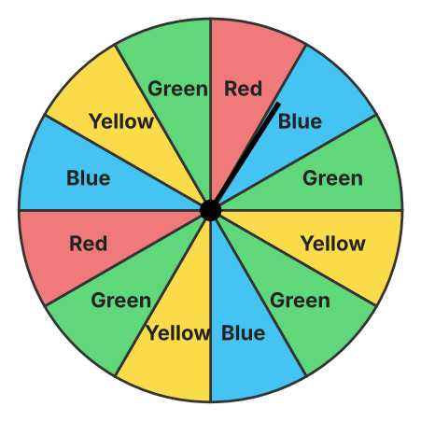  Observe the spinner above. Each section is the same size.  a) List the sample space:  b) What is the probability of spinning yellow?  c) What is the complement of spinning green, and what is its probability? | 3  marks

